Migration: A permanent change in residence

Not temporary change (seasonal workers, travel, etc.)

Internal Migration: Ppl within a country moving to another location within the same country

Inter (between): state, region

Intra (within): state, region, urban (migration w/in the same city or town

Interstate, intrastate, interregional, intraregional intraurban

Intraurban Migration: Moving homes (addresses) within an urban area

You change addresses, but often stay close enough to maintain jobs, school districts, friends, etc

The most common form of internal migration

Common reasons for intraurban migration:

House size

Neighborhood location

etc.

This area is of growing attention to geographers who have traditionally focused more on larger moves

Intrastate Migration: Change cities, but stay within the state

Common reasons:

Jobs

Education

Often rural to urban migration (particularly of young adults (ages 17-25))

Interstate migration: Moving from one state to another

Common reasons:

Jobs, careers

Education

Traditionally demographers have focused most heavily on this form of migration, but recently attention has tended to start shifting down to smaller scales

How to Measure Migration

International Migration:

Visa Applications

Border Control / Immigration

Census / Surveys

Internal Migration:

Census / Surveys

IRS

In the US, internal migration is measured based on changes in address within the past year (this is a question on your taxes every year and is part of the American Community Survey)

Discussing International Migration

Net Migration = Immigration – Emigration

Discussing Internal Migration:

Net Migration = In-Migration – Out-Migration

Crude Net Migration Rate

Shows if population is growing or shrinking

If Washington gets a lot of people moving in and lots moving out, the CNMR can look the same as a state with few people moving in and few moving out. Total Migration Rate and calculate this.

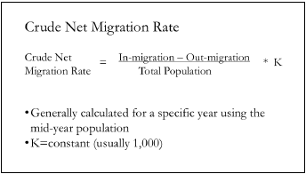

Total Migration Rate:

Measures what fraction of the population is migrating (changing addresses). It does not tell you whether the population is growing or shrinking (need the CNMR to do that).

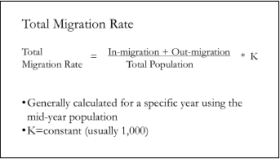

Internal Migration in the US

US has a very high rate of internal migration (compared with other countries), but it is now on the decline

Reasons for decline in rate of internal migration:

Population growth in the least mobile groups (elderly, homeowners, etc.)

Rise in dual career couples (moving for one job is relatively easy; moving because two jobs lines up is significantly harder

Rise in divorce rate (divorced parents choose to stay near their kids)

Deunionization (workers less mobile bc it’s harder to bargain for a higher paying job elsewhere)

Labor Market Convergence (labor markets w/in the US are starting to look more and more alike so there is less motivation to move elsewhere to access a better labor market)

Great Recession and Foreclosure Crisis (actually initially increased intracounty / intraurban mobility as houses were foreclosed, but dramatically decreased intercounty/interurban mobility (ppl don’t have the money to start over elsewhere

Large Historical Migration in the US

Western Frontier (17th c. – 19th c.) (since European settlement of North America began, there was a slow shift in pop westward as land became available. Most motivated by economic gain (some by religion freedom, e.g. Mormons))

The Great Migration (1910 – 1970) (migration of Blacks from the rural south to the urban north and California. Approximately 1.4 million African Americans moved. Some scholars break it into the First (1910 – 1940) and Second (1940 – 1970) Great Migrations. Shift of the African American pop from over 90% rural to over 90% urban. There is also the movement of African Americans w/in the south into cities, but not at the rate of moving north.)

Westward / Sun Belt Migration (In the middle of the 20th c., Americans migrating south and west both for retirement and for jobs)

US is Republican by Area, Democrat by Population